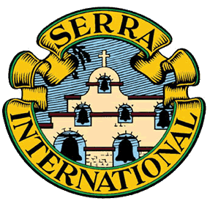
Serra Club Board Meeting | January 21, 2021, 5:00pm
Attendees:
- Jo Helling, President
- Tom Farley (phone), President Elect
- Bill Cook, Treasurer
- Judi Eilertson, Secretary/Vice President of Communications
- Victoria Carver, Trustee
- Larry Schmidt, Vice President of Vocations
- Jerry Murphy (phone), Trustee
- Susie Flood (phone), Trustee
Phil Huss, Adoration
Open Position: Vice President of Programs
- The meeting was called to order with an opening prayer by President Jo
- October 2020 minutes were read and approved (Bill/Larry)
- Treasurer Report (Sep-Dec 2020) was presented by Bill and approved
- December 31, 2021: 124 members, (down from September 2020):
  - 4 members passed, 5 did not renew, 1 moved from DM
- Ordination Gift (June 12, 2021):
  - Motion passed to give $1,000 to each of the 5 new priests. The gift will come from the Serra Investment Fund that is held with Southwest Iowa.
Old Business:
- Bishop’s Burse (see income and expenses above (-$1,223.03)
- 2021 Serra Calendar
- Catholic Schools Week (Jan 31-Feb 6) Jim Henscheid delivered seminarian prayer cards to the local Catholic grade schools
New Business:
- Sister Appreciation Event (May Baskets)
  - Committee: Denise Farley, Geri Boesen, Susie Flood and Judi Eilertson
  - 39 retired Sisters, Jo will request a member collection to finalize the budget (generally, $50/sister)
  - Judi will take items to Geri on Wed, April 28 (4324 Ashby Ave, Beaverdale)
  - Baskets will be delivered on Friday morning, April 30. Jo will request volunteer drivers
- Revisit the Farm Bureau Luncheon planning for May 21, July 16, and/or October 15.
- Consider moving BOD meetings from Thursday to Wednesdays due to standing conflicts by current Trustees.
Vocations Report:
Upcoming Events:
- Seminarian Appreciation – lunch (August)
- New board members will transition in July
  - Jerry Murphy, Treasurer for Bill
  - Jo will ask David Pieper if he would be interested in taking the VP role for Jerry
- Priest Appreciation - picnic (September)
  - Jo will ask Pieper’s and Mahoney’s if they are able to chair the Priest Appreciation Cookout
The next board meeting will be held on Thursday, April 15 at 5:00pm (location TBD). The meeting was adjourned with a closing prayer by President Jo.

