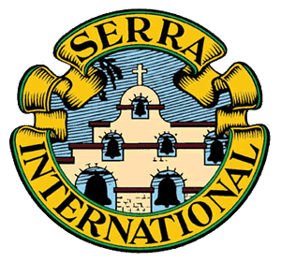

Serra Board
Meeting
April 16, 2020
5:30pm

Meeting as called to order by Jerry Murphy with an opening prayer

Attendance: Jerry Murphy, Jim Hensheid, Tom Farley, Jo Helling. Susie Flood, Victoria Carver, Larry Schmidt, Mike Downey.

Minutes from the last meeting were approved

Bill Cook presented the Treasurer Report and it was approved

Jerry has received 13 new member kits for our new member inducted at out dinner in February at Tumea and Sons.

Sister’s Appreciation Dinner

Due to the COVID -19 pandemic the dinner for this year has been cancelled. Since this is an important program of our club, we are looking at alternatives. Jerry has asked from the membership a discretionary contribution so we can continue this program. Bill Cook said we have received $2000. In contributions within the past few weeks. We actually only need $1100., so with an additional $900. Jerry has asked the dinner committee, headed by Denise Farley to come up with some ideas on how we can appreciate the Sister’s. Denise will be meeting with the committee in the next few weeks and will present their ideas to the Board.

Monthly Meeting April 17, Farm Bureau

Again, due to the COVID-19 pandemic this meeting was physically cancelled, only to be scheduled virtually on the same day instead. Father Ross Parker was the scheduled speaker. Due to technical difficulties this did not happen. The meeting was rescheduled virtually for Monday, April 20th at noon. Father Ross will be speaking as scheduled.

Teams of 7

Susie Flood reported on the Team of 7 project. This program is designed to pray for the local Diocesan Vocation Directors. We have one completed team now paying for Father Ross Parker. Each team member takes one day and says special prayed for that Vocational Director. We are also looking to develop another team to pray for the Vocational Director in Madison, Wisconsin, Father Imes. It was also suggested that each team member write a note to their vocational Director letting them know that prayers are being said for them.

Weekly Rosary

There was mention of the Rosary being said weekly for Seminarians. Is this still happening? We used to have 49 members doing this.

Post Pandemic

- Celebration dinner (Father John)
- May Meeting, speaker Bishop Joensen
- June 12 ordination
- Seminarian Lunch – August
- Priest Appreciation Picnic – September

Membership Directory

Jerry Murphy will be working on updating the membership directory

Meeting was called to close with a closing prayer.

